**DOCUMENTATION FOR WORLD HAPPINESS REPORT DASHBOARD**

The World Happiness Report is a publication of the Sustainable Development Solutions Network, powered by the Gallup World Poll data. They used observed data on the six variables and estimates of their associations with life evaluations to explain the variation across countries. These variables include GDP per capita, social support, healthy life expectancy, freedom, generosity, and corruption. This is on the premise that more people have come to believe that the success of countries should be judged by the happiness of the people.

The dataset was gotten from a google drive by opening the link of the folder using Google spreadsheet on a web browser, removing restrictions, copying the web link and pasting on the “From Web” option in dropdown menu in Get Data portion on the Power BI desktop then loading into Power query editor for onward cleaning and transformation.

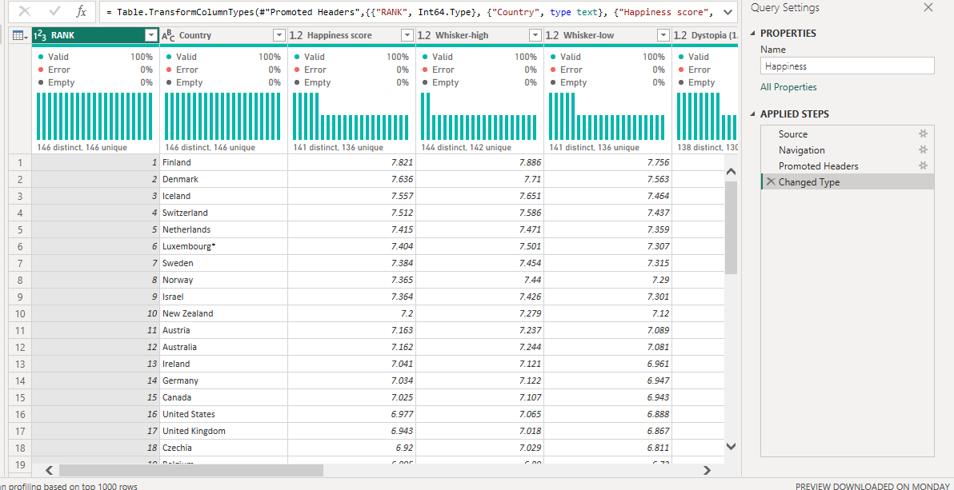

The data looked clean having 12 columns, 146 rows without nulls or blank cells. Then I closed and applied for onward visualization and building of the dashboard as it is below.

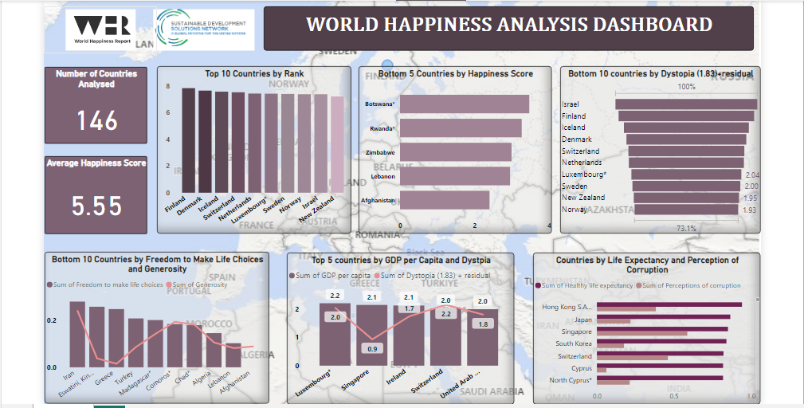

**Insights**

**146** countries were analyzed, and the average happiness score was **5.55** based on these indices: Social support, Freedom to make life choices, GDP per capita, Healthy life expectancy, Generosity, Perceptions of Corruption and Dystopia 1.83 + residual.

Finland had the highest rank, followed by Denmark and Iceland while Afghanistan, Lebanon and Zimbabwe are the 3 countries that ranked the lowest. 74 countries had a score greater than the average Happiness score of 5.55.